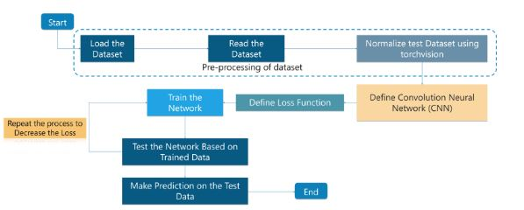

**[ We first provide some data and it is loaded. This dataset is then read and we normalize it to sort all the properties and features of the data. This is then defined using the 'Convolution Neural Network (CNN) which helps us analyze the various aspects of the image and helps in differentiation. The loss percentage is calculated and we train the data. We then test the data and this process is repeated to reduce the loss percentage and improve the accuracy.. The final prediction is then made using this dataset. ]**